**WEEK-6**

**React JS Handson-5**

1. I extracted the given ZIP React application and opened it in Visual Studio Code.
2. I restored all the required packages using npm install in the terminal.
3. I created a new CSS module file named **CohortDetails.module.css** under the src folder.
4. In this CSS file, I defined a class called .box with styles like width, padding, border, and margin.
5. I also styled the <dt> tag to make it bold and readable by setting its font weight to 500.
6. I added two more classes .ongoing and .completed to color the status text green and blue based on cohort status.
7. I then opened the **CohortDetails.js** file and imported the CSS module using import styles from './CohortDetails.module.css'.
8. I applied the box class to the outer container <div> using className={styles.box}.
9. I added logic to apply either styles.ongoing or styles.completed to the <h3> tag based on whether the cohort is ongoing or completed.
10. Finally, I ran the app using npm start, opened localhost:3000, and saw a styled list of cohort details with color-coded statuses.

**CohortDetails.js**

import React from 'react';

import styles from './CohortDetails.module.css';

function CohortDetails(props) {

  const { cohort } = props;

  const statusClass = cohort.currentStatus.toLowerCase() === 'ongoing' ? styles.ongoing : styles.completed;

  return (

    <div className={styles.box}>

      <h3 className={statusClass}>

        {cohort.cohortCode} - <span>{cohort.technology}</span>

      </h3>

      <dl>

        <dt>Started On</dt>

        <dd>{cohort.startDate}</dd>

        <dt>Current Status</dt>

        <dd>{cohort.currentStatus}</dd>

        <dt>Coach</dt>

        <dd>{cohort.coachName}</dd>

        <dt>Trainer</dt>

        <dd>{cohort.trainerName}</dd>

      </dl>

    </div>

  );

}

export default CohortDetails;

**CohortDetails.module.css**

.box {

  width: 300px;

  display: inline-block;

  margin: 10px;

  padding: 10px 20px;

  border: 1px solid black;

  border-radius: 10px;

}

dt {

  font-weight: 500;

}

.ongoing {

  color: green;

}

.completed {

  color: blue;

}

**App.js**

import logo from './logo.svg';

import './App.css';

import { CohortsData} from './Cohort'

import CohortDetails from './CohortDetails';

function App() {

  return (

  <div>

    <h1>Cohorts Details</h1>

    {CohortsData.map(cohort => <CohortDetails cohort={cohort}/>)}

  </div>

  );

}

export default App;

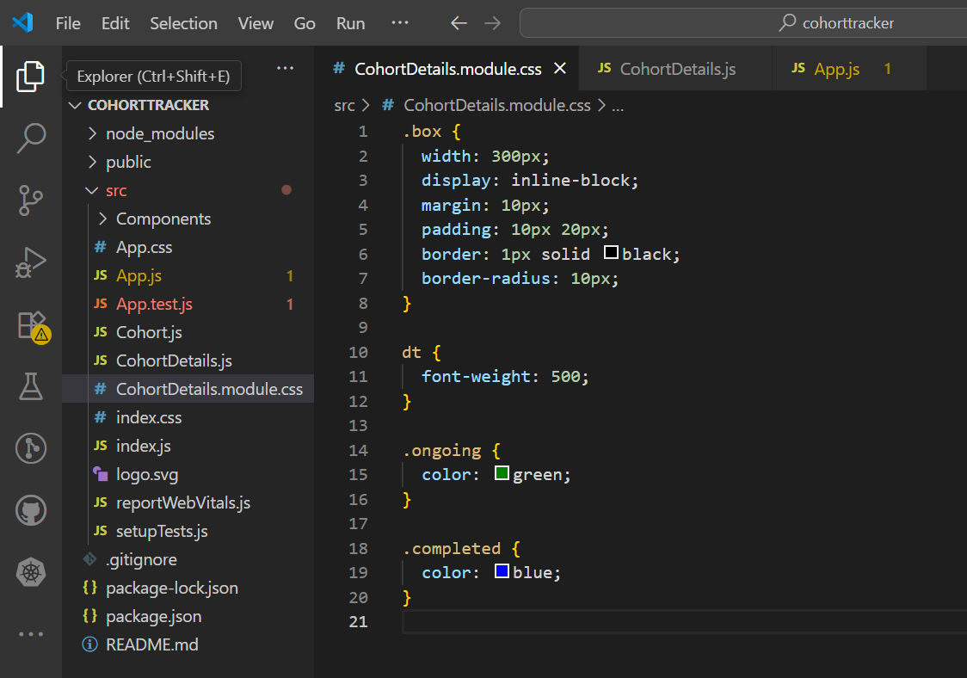

**OUTPUT:**

